AUBURN UNIVERSITY

Senior Design
Final Report
Group 1- Robocopter

Edward Budimier
Adam Gould
Jens Johnson
David Mason
Shaquana Peterson

Table of Contents

- Summary--------------------------------------------------------------------------------------------------------------------3
- Project Description (David Mason)

- Team Interaction----------------------------------------------------------------------------------------------------------4
  - Team Management (David Mason)
  - Team Dynamic (Jens Johnson)
- Design -----------------------------------------------------------------------------------------------------------------------6
- Design Process
  - Design Selection (David Mason)
  - Concept Designs (David Mason)
  - Approach (Adam Gould)
  - Design Requirements and Specifications (Adam Gould)
  - Design Adjustments (Adam Gould)
  - Modeling and Simulation (Adam Gould)
  - Implementation (Adam Gould)
  - Testing (Adam Gould)
- Component Design Details
  - Balance Report (Shaq Peterson)
  - Arduino Fio Testing (Adam Gould)
  - xBee Wireless Communications (Jens Johnson)
  - Power Supply for PING))) Ultrasonic Sensors (David Mason)
  - Testing and Prototyping the PING))) Ultrasonic Sensors (Ed Budimier)
  - Control Logic (Jens Johnson)

- Logistics---------------------------------------------------------------------------------------------------------------------3
- Timeline (Ed Budimier)
- Budget (Shaq Peterson)
- Inventory and Components (Shaq Peterson)

- Review of Project--------------------------------------------------------------------------------------------------
  - Accomplishments (Jens Johnson)
  - Reflection (Jens Johnson)
  - Design Team (Jens Johnson)

Summary

Project Description

David Mason

Team 1, Project Autonomous Helicopter consists of five team members working together to develop an autonomous flight system for an RC helicopter.

To call the project a success the flight controls need to be completed to a point of having the ability to take off and land without human intervention. This should be accomplished using a microcontroller, three motor driver circuits, at least one range finding sensor, and a power regulator to provide regulated voltage to the sensor.

TEAM INTERACTION

Team Management

David Mason

With every team there is a leader. Someone who maintains the team’s focus and ensures all deadlines are met. A team leader must be a responsible individual willing to handle the pressures involved with leading a group toward a common goal.

In order to maintain a sense of progression throughout the semester long senior design project Team 1 decided to split certain responsibilities between group members to give each individual team member their own responsibilities. Some of those responsibilities included: budgeting, editing, circuit design, circuit testing, programming, sensor testing, and prototype designing. While there were individual responsibilities there were also shared responsibilities such as: meeting, brainstorming, testing, and designing. Each team member was also responsible for documenting their personal accomplishments and designs and testing done. Each person’s contributions were made known to the rest of the group during team meetings to ensure no overlapping occurred.

During team meetings, which were held at least once a week, all the team members joined together to discuss their accomplishments from the previous week and to discuss design goals for the next week. Throughout the week individual members may be contacted by the team leader to check on progress and to determine if those individuals needed help in accomplishing their goals. The team leader made himself available for phone calls at all times and tried to make sure the team felt comfortable communicating their thoughts and ideas to him. One of the main advantages of having a team leader is to ensure that open communication exists between the team members. The team leader could essentially be thought of as a main hub where all the ideas, progressions, obstacles and designs were centrally located.
While managing a team of engineering students it is important to maintain focus on the role the team leader is supposed to play in the group. It is easy to get caught up in the fact that a deadline is coming up and try and do the work for the team rather than be a resource the team uses for instruction and motivation. A team can fail to accomplish its greatest goals if the team leader becomes discouraged so it is important for the leader to compartmentalize his responsibilities and make sure the team stays on task.

Team Dynamic
Jens Johnson

One of the really important learning points of this project was learning how to work with a group. Sometimes it’s really easy to overwork or under-work on a project. Learning how to communicate with one another and dividing up the work was, at times, difficult. Coordinating submission work for deadlines was very stressful. As a whole, however, our group had a lot of interaction and solid lines of communication. We developed a good relationship early. This made discussing ideas easy as we were comfortable to express our concerns or support of a particular suggestion.

DESIGN

Design Process

Design Selection

David Mason

At the beginning of the design process the team decided to use an air to ground transmission system to provide feedback to a ground control unit which in turn transmitted the necessary controls to the helicopter. The hardware used for completion of the project has changed slightly to avoid over complication of the project. When problems interfacing to the helicopter’s manual controls occurred the team chose to put a little more faith in their coding abilities and only use one microcontroller. The one microcontroller interfaces with at least one ultrasonic range finder to judge altitude during a take-off and landing routine. The microcontroller is also interfaced to a motor controller built by the team to handle the power requirements of the helicopters various motors.

Concept Designs

David Mason

Throughout the semester many different design alternatives were conceived. As with any design process all of the different ideas need to be documented whether used or not. Some of the teams previous design considerations included the following: a dual microcontroller setup with wireless communications, a transmitter/microcontroller integration which allowed the microcontroller to manipulate the RC transmitter, a vision system which used an IR distance detector, a helicopter that could use GPS to track its location, a helicopter that could virtually map the dimensions of a room, and a single ultrasonic sensor mounted on a hinge that could measure both forward obstacles and altitude when adjusted, just to name a few. Some of these design concepts are documented below.

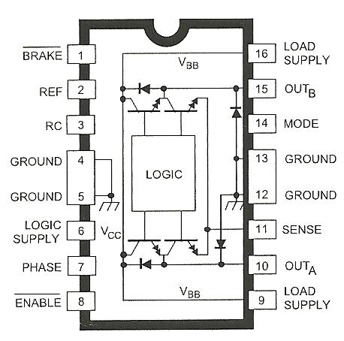
The picture to the left shows a 3953 PWM full bridge motor controller which was tested for use on the rear motor of the helicopter to control forward and backward motion. Unfortunately the motor controller was never made to work and was eventually abandoned for a simple switching circuit which would only drive the helicopter forward. The team ultimately decided that as long as a forward obstacle was detected in a sufficient amount of time the need for reverse could be eliminated.

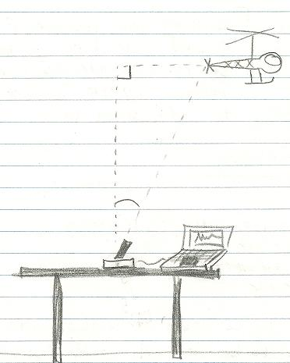
The drawing to the right shows an early concept of position calculating based on trigonometry. The idea was that a web cam with swiveling capabilities would track the position of the helicopter by calculating the angle the camera was pointing. This information could then be used to create a three dimensional map of the room.
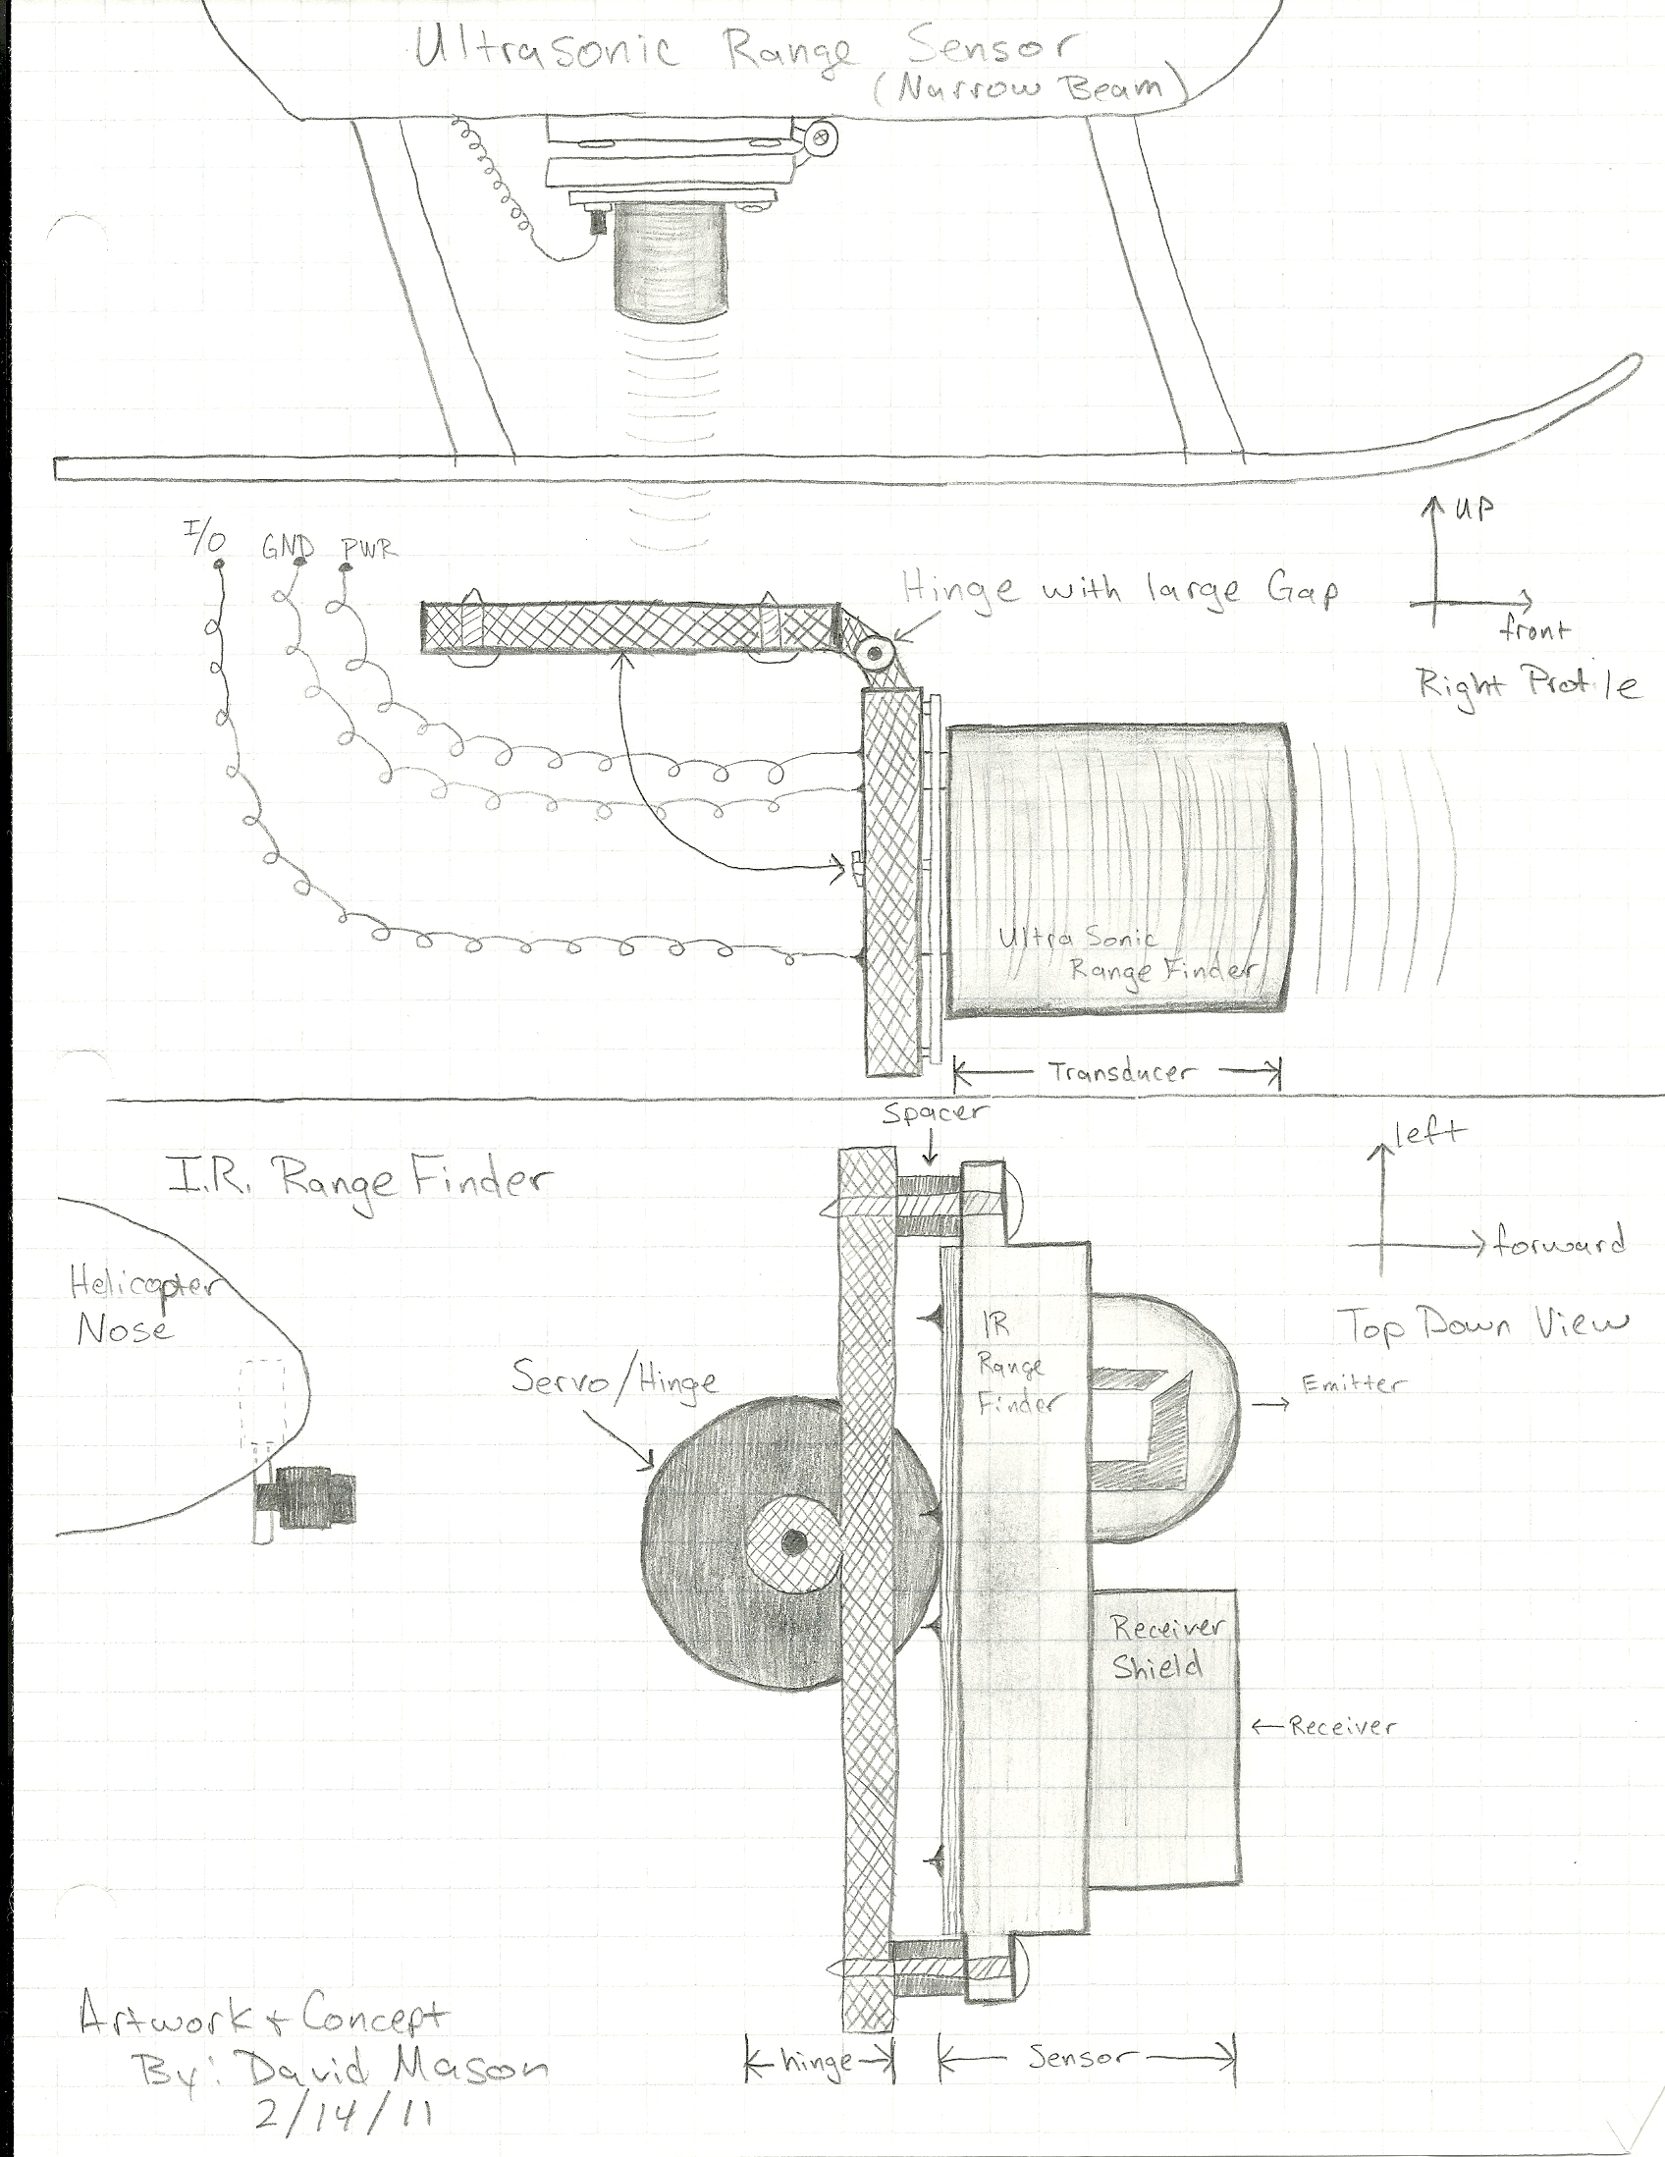

The drawing to the left top shows a design that would utilize only one ultrasonic sensor. The sensor was to be mounted on a hinged plate that could, using a servo, face the sensor to the front of the aircraft or to the floor. The idea was that once the helicopter reached the desired altitude, the motor speed would be saved and made constant. This would free up the altitude sensor which could then be used as an obstacle detecting sensor.

Another design idea was to use an IR distance sensor mounted to the front of the helicopter. The sensor would use a servo to rotate left and right to detect obstacle in the full path of the helicopter rather than just straight forward.

Approach

Adam Gould

The design that our team sought to achieve was a small scale electrically powered helicopter that can fly on its own without any user input. To accomplish the design our team would approach it in a five step methodical approach. The five step of the design process are as follows:
>Design Requirements and Specifications
>Design Alternatives
>Modeling and Simulation
>Implementation
>Testing
Each of the five steps was approached in some fashion.

Design Requirements and Specifications

Adam Gould

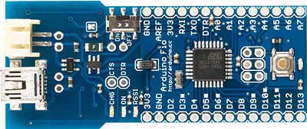
To achieve the requirements and specifications of the design several criteria and conditions were necessary to meet. The main such necessity was that the team implement a process by which every motor on the helicopter can be controlled with regards to speed and timing using an autonomous process. The most reasonable means to do this was to use a microcontroller. A microcontroller possesses the capabilities that were needed for this. One limiting factor in choosing a microcontroller was weight and form factor. On this basis the team chose to employ an Arduino Fio microcontroller. I was small, lightweight and had the necessary processing power for our needs. The Arduino Fio would essentially become the “brain” of the autonomous helicopter.

If the Arduino Fio is the brain, it may be helpful to think of the three motors onboard the helicopter as the muscles. There are three motors located on the helicopter. Two main motors and a tail motor. Each of the two main motors controls a single set of rotor blades of which there are two. These two set of rotors are what the helicopter uses to achieve lift. By varying the speed of one set of blades with respect to the other it is possible to make the helicopter turn. The tail motor controls the tail rotor. The tail rotor is bidirectional. By spinning it in one direction in causes the tail to lift which in turn pitches the nose of the helicopter down slightly. Even this slight pitch is enough to cause considerable forward motor of the helicopter. Likewise if the tail rotor is spin in the opposite direction it will cause the tail to pitch down. This will in turn tilt the nose of the helicopter up. Even this slight tilting of the nose is enough to cause backward motion of the helicopter. By varying the speeds of these three motors it is possible to navigate the helicopter in any direction on the x,y,z axis while flying will the helicopter oriented forward or backward. This gives the helicopter a nearly unlimited range of motion.

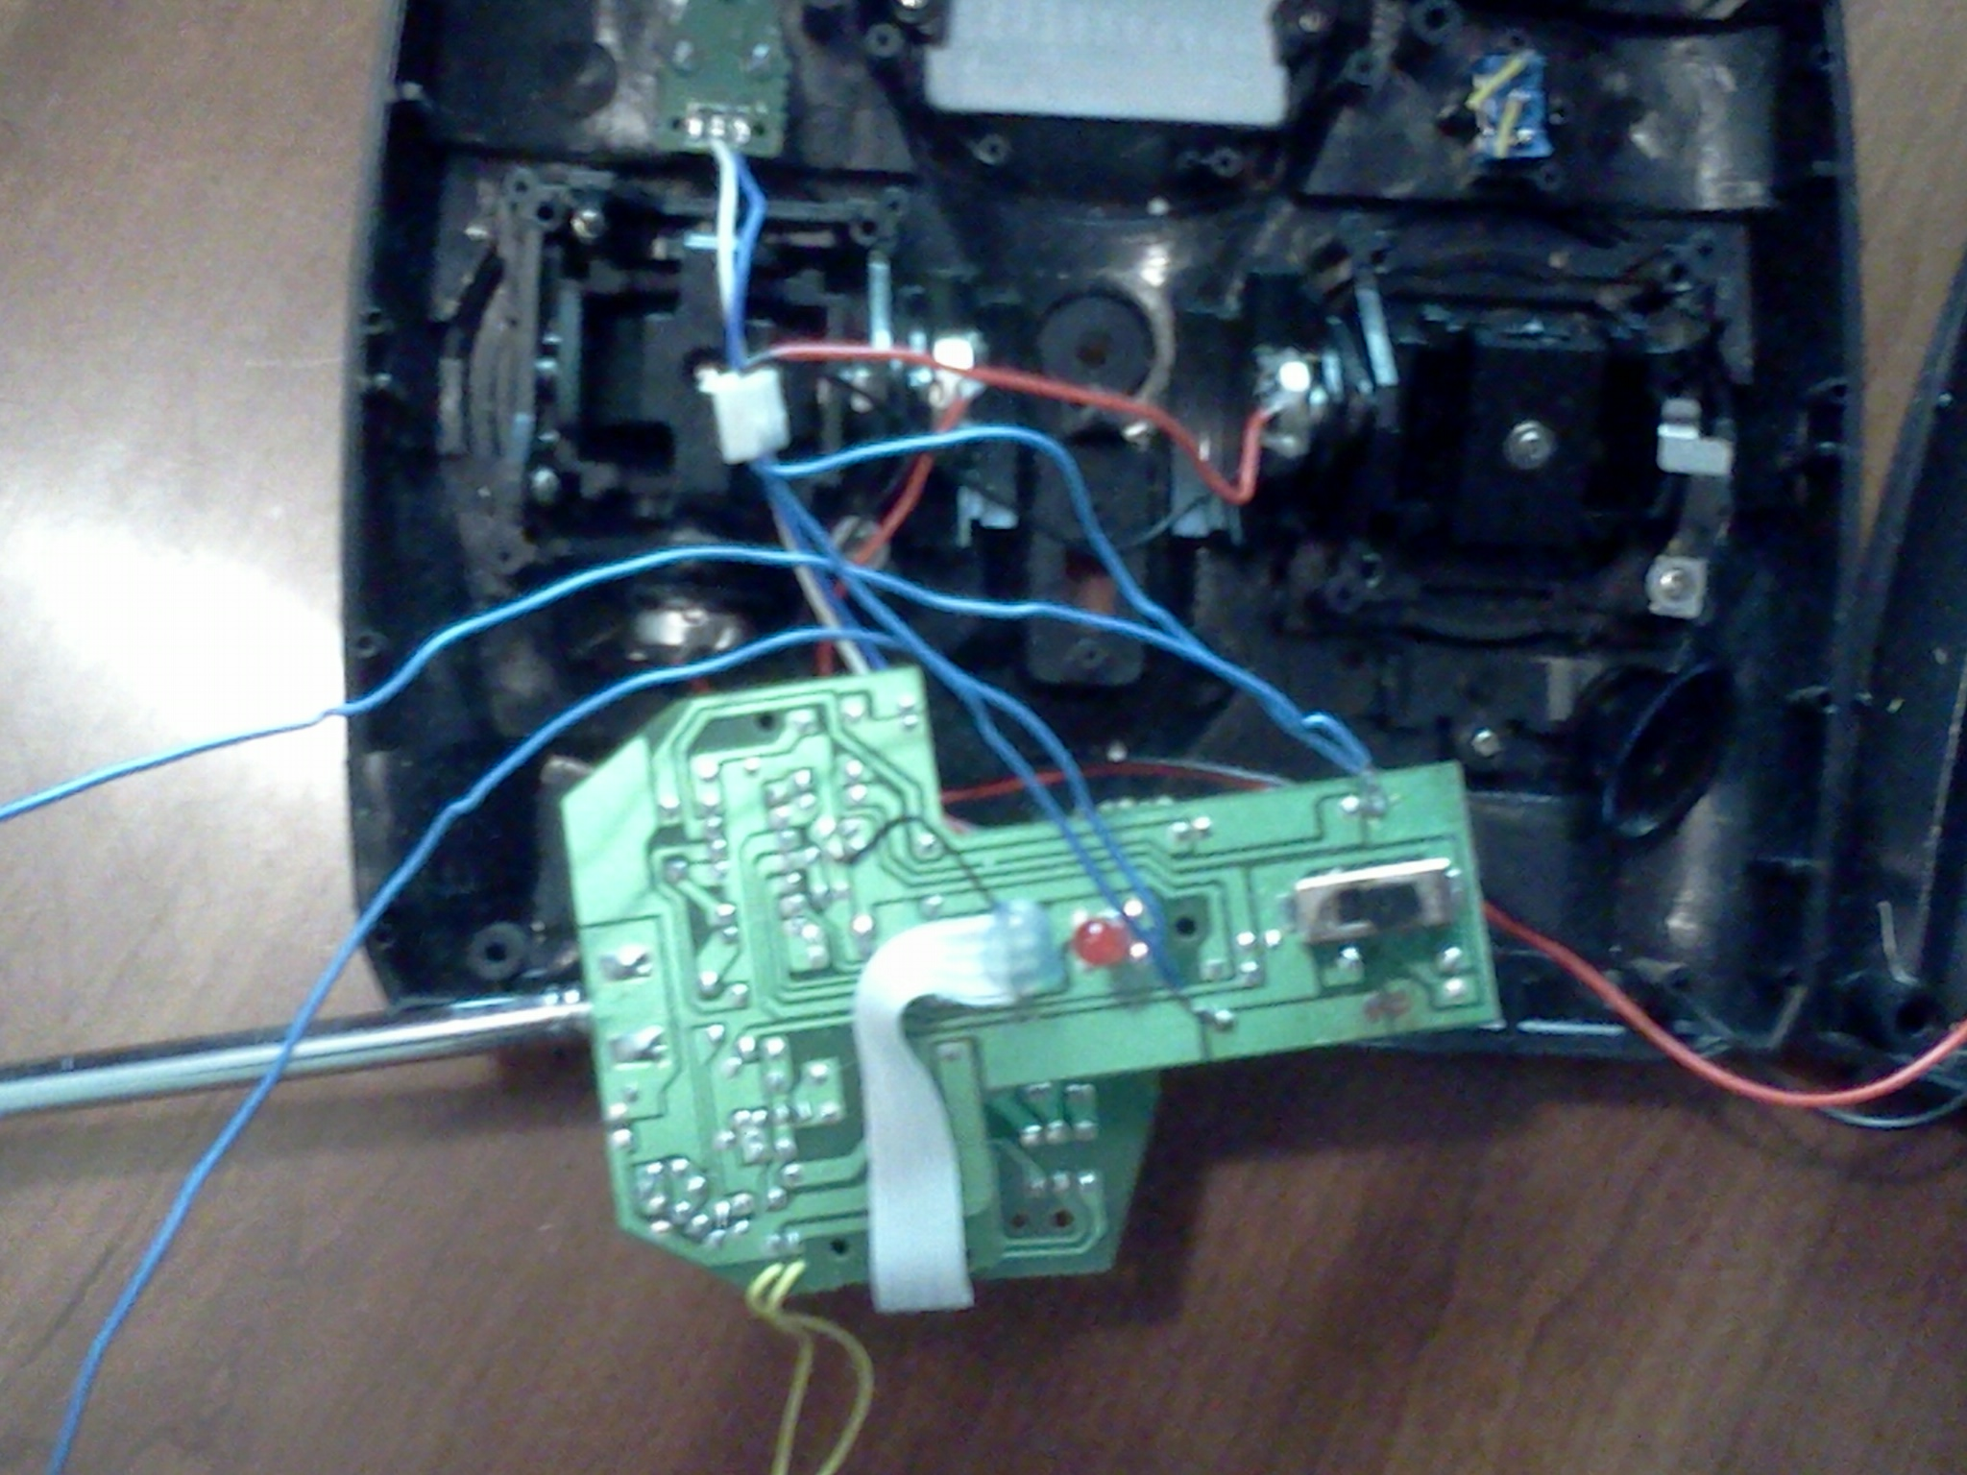
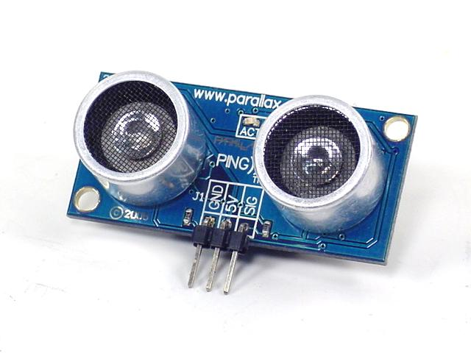
The “eyes” of the helicopter come in the form of Paralax ultrasonic sensors. One or more of these sensors would be mounted on the helicopter to detect objects and the environment around it. In this way the helicopter would gain an “intelligence” so to speak. The eyes see an object. The eyes sent this information to the brain which processes it and activates the muscles accordingly.

The next step in the design process was to devise a way to interface the brain and the muscles. There were many possible ways of going about this. The team chose what seemed to be the fastest, simplest, and most cost effective option at the time. This option was to use the remote control that the helicopter originally came with when purchased to control the motors.

The idea was to integrate the Fio into the remote control. The Fio would tell the remote what signal it wanted sent. The remote would then send the appropriate signal wirelessly to the helicopter. This signal would be received by the control board on the helicopter which would then in turn spin the motors at the specified speed.

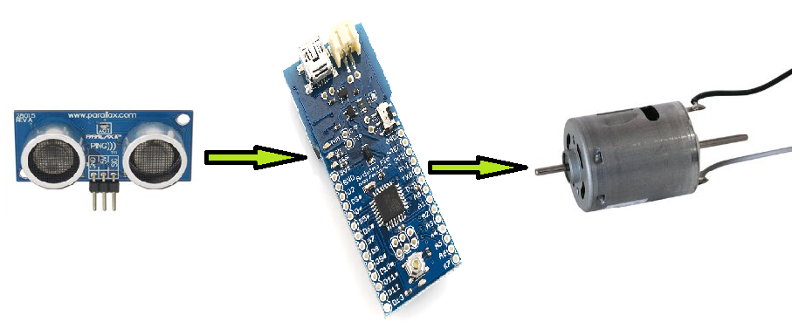
This approach was wrought with various difficulties. The first and most problematic of these was that the only signal that the team could successfully send from the remote to the helicopter by means of the Fio was a high signal. The design requires that the motors be able to spin at various speeds making this approach was not applicable.

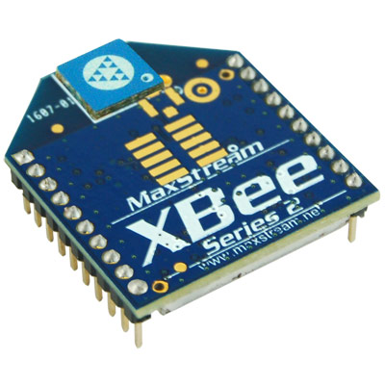
Another issue was that this approach would require the use of two microcontrollers. One of the Fios would be located on the remote control and the other would located on the helicopter. The Fio on the helicopter would receive information from sensor and then need to in turn send that back to the Fio on the ground so that it could decide what to do. Another concern arose as to how would the two Fios communicate with each other. A solution was found in use of miniature XBee Radios.

Each XBee radio would receive and transmit information between itself and the other. The problem was this is that the only way in which the XBees can communicate between Fio is by uploading information onto each other. The uploading process takes a matter of seconds and the design requires that the decisions that the helicopter must make be in the order of milliseconds. What seemed simple at first turned into a complicated and inefficient method. This led the team to investigate design alternatives.

Design Adjustments

Adam Gould

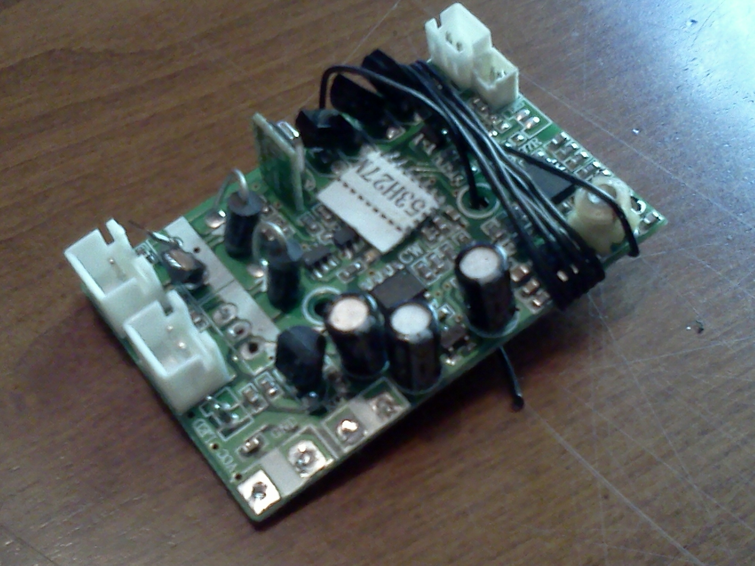
The team’s first approach at interfacing the Fio with the motors was perhaps not the best so another had to be devised. One idea was to connect the Fio to the control board on the helicopter and control the motors through it . This option was quickly ruled out to the team not possess the schematics for the helicopter mounted control board and having little notion of how it worked. The next option was to control the motors directly from the microcontroller. The battery that powers the microcontroller isn’t near large enough to run the motors and the microcontroller cannot handle the power of the main helicopter battery flowing through it so a new option was conceived. The option was to for the team to build its own motor controller. This approach began by researching possible motor control circuits in text books and online. After some research a possible motor control circuit design was found.
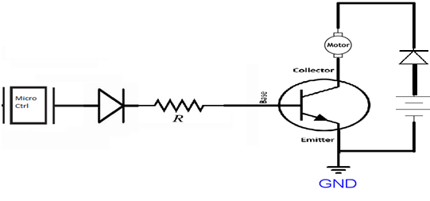

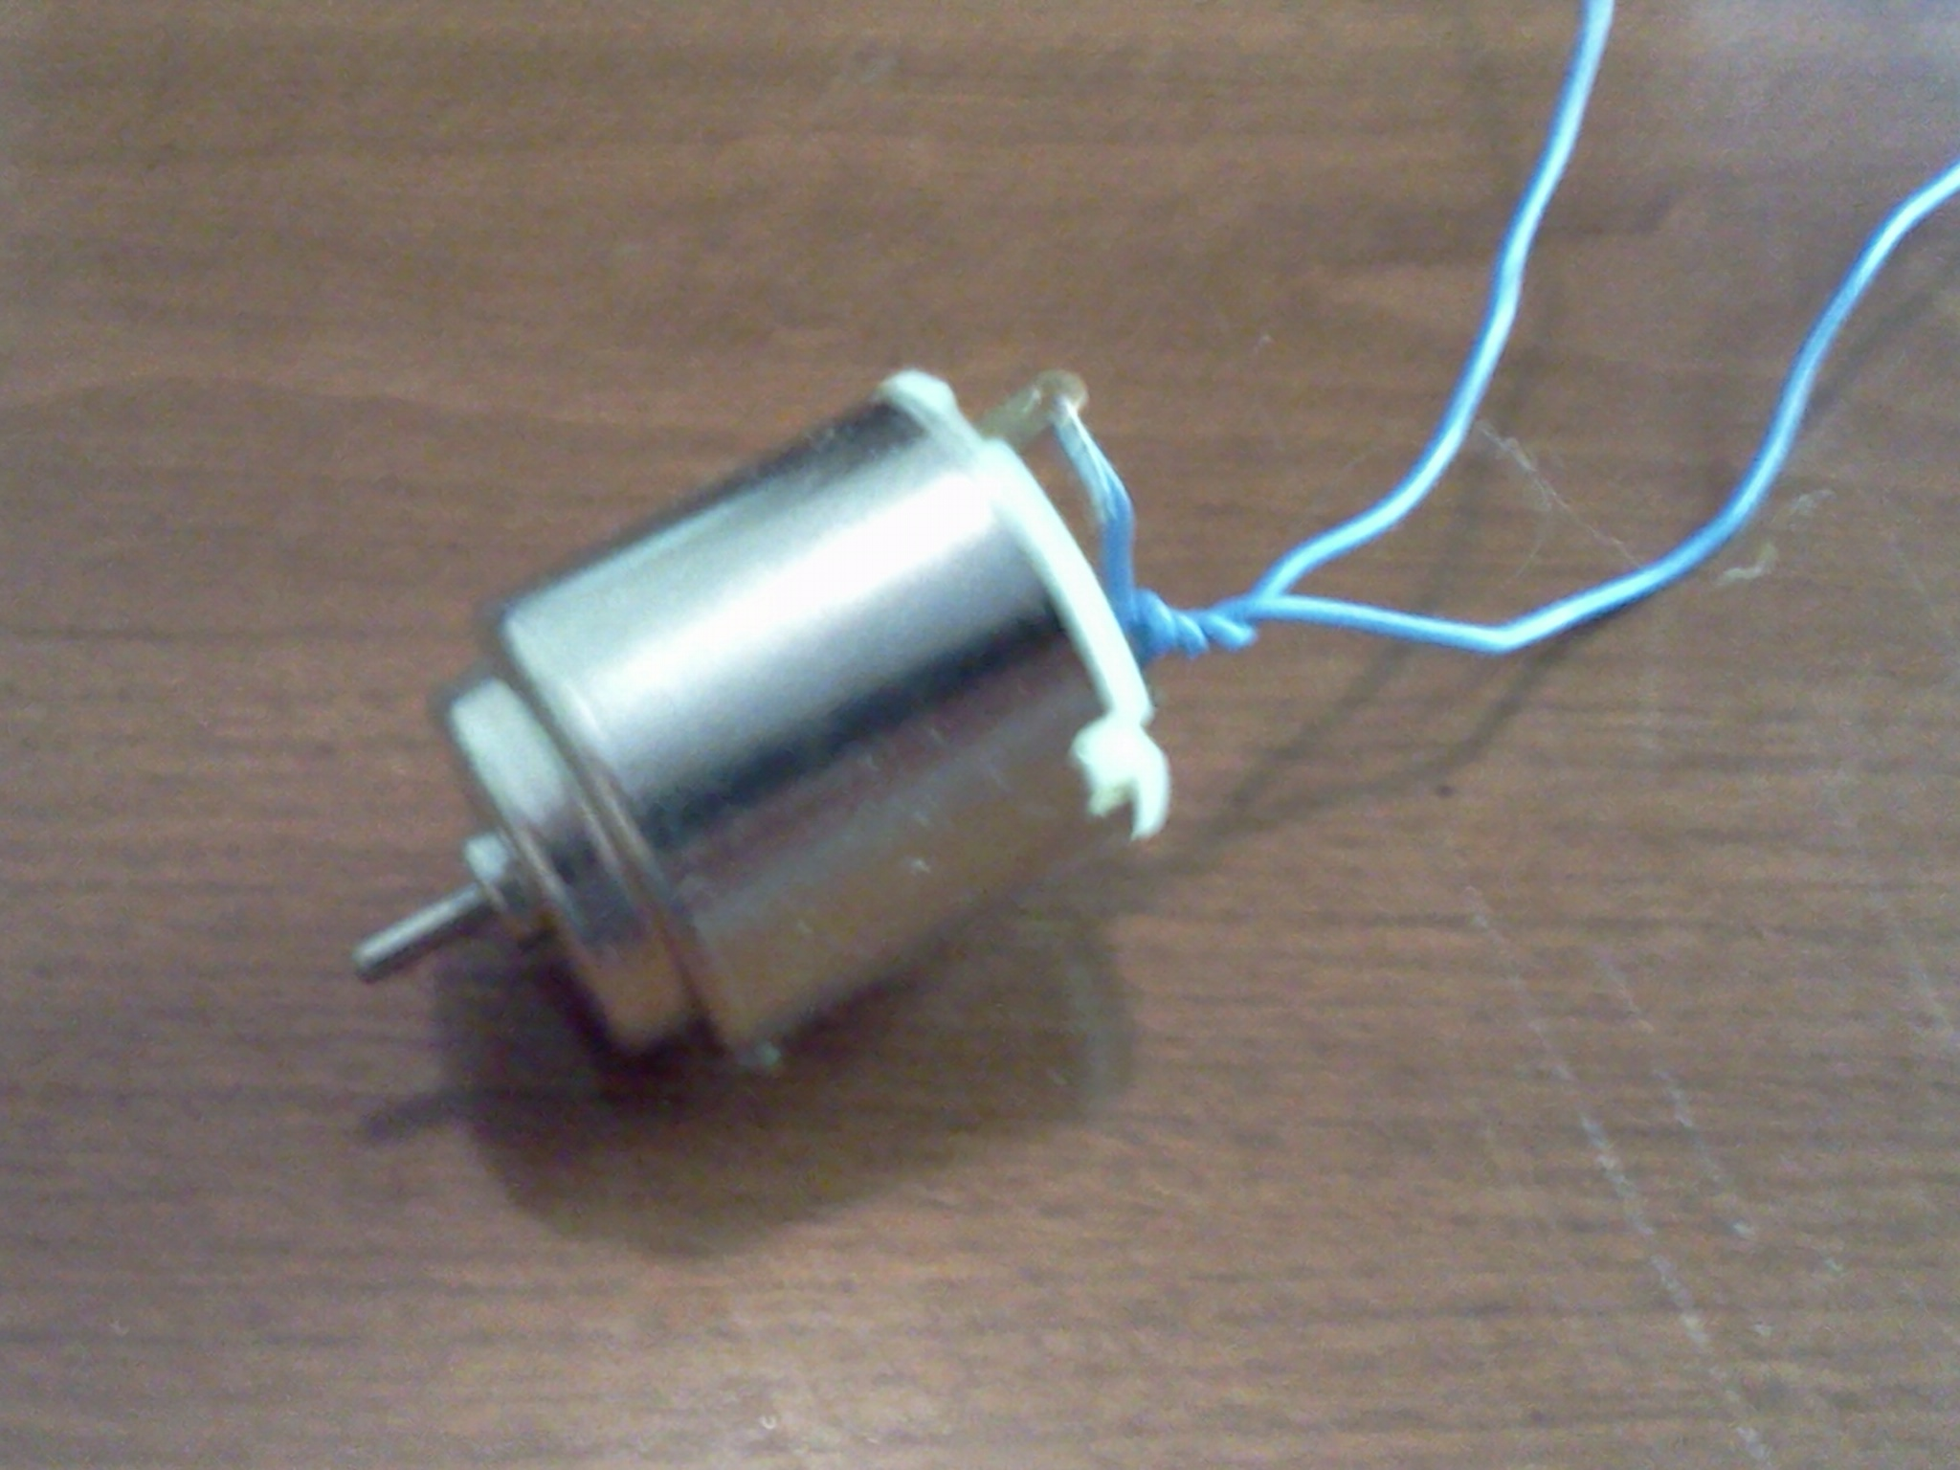
The team then tested this circuit using a AA NiMh battery and a hobby motor.

The set-up worked wonderfully. The subsequent step was to test this set-up using the main helicopter battery and motors. The result was that the 2N3904 burst into smoke.

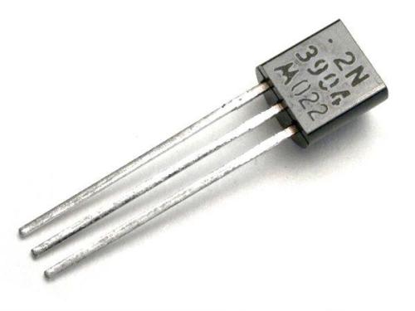
It was assumed that the helicopter motors drew too much power for the 2N3904 to handle. In the future it would be seen just how true that was.
To solve the problem of the transistor not being able to adequately handle the necessary power a multitude of other Bipolar Junction Transistors were tested. These included the 2N3055 and the TIP2120. These faired a little better. The team was able to run a simple motor control program meant to run a single from Min to Max power in increments. Despite this success the transistors still became extremely hot in a matter of seconds and eventually failed. Testing of this set-up resulted in a vast number of destroyed transistors.

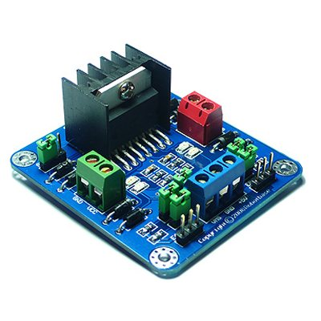
With the deadline of the design growing more and more eminent the team decided to go ahead and order a commercial motor controller. A multi-meter was used to test the current being draw from each of the main motors with the blade taken off the helicopter. Each motor was drawing between 1.4 and 1.5 amps. With this knowledge the team chose to purchase a commercial motor controller capable of driving two motors up to 2 amps a per motor. Once the commercial motor controller arrived in the mail the team immediately tested it. Unfortunately it was only able to spin the motors at around 25% of their maximum speed. Not nearly fast enough to attain lift-off of the helicopter.

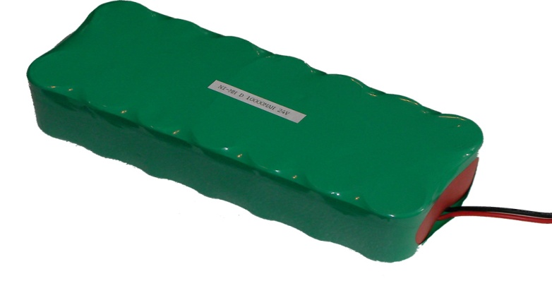
After a good deal of puzzlement as to why this was happening, the team had the idea to try and send more power to the motor controller. Using a power supply provided by Auburn Electrical Engineering Department the team tried various power settings to see if there would be any result. Surprisingly sending more power to the motor controller did indeed speed the motors up some. After a good deal of testing it was concluded that more voltage up to a point caused the motors to spin faster. This brought up a new issue. It appeared as though a new a battery with more voltage and capacity would have to be purchase to get the commercial motor controller to work. However, prices of lithium polymer batteries and chargers were prohibitively expensive. Because the team already had access to NiMh AA and AAA quick charger, the idea to create a homemade battery pack out of AA batteries would be more reasonable.

The problem with this was that to create a battery pack capable of running the motors at top speed while using the commercial microcontroller, said battery pack could create a weight issue. To ascertain whether or not the helicopter could lift the homemade battery pack, the blades needed to be reinstalled. With the blades installed again the commercial motor controller was tested with the homemade battery pack. To the dismay of the team the motors spun at around 50% of their max speed. It didn’t work. The team then started to try and diagnose why the commercial motor controller was not working as desired. The current being draw by the motors was tested again. Due to the added load of the blades being added each motor was drawing 8 amps! This would explain why the commercial motor controller was not working well. It was only rated for 2 amps per motor and they were trying to draw 8 amps at full power. It was also concluded the lithium ion battery on the helicopter was capable of providing over 16 amps to the helicopter whereas the homemade battery pack was not. It was back to the drawing board.
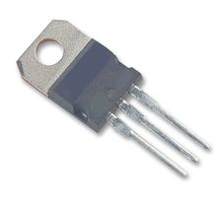
The deadline for the design to be completed was drawing more and more near. The only thing that was left to try was to go back to building a motor controller. There had been a small amount of success from the homemade motor controller but there was still the issue of heat. For the homebuilt motor controller to work the heat problem had to be solved. Through a large amount of brainstorming and research a possible solution was devised. The first was to use high power NTE 2984 MOSFETs more suitable for handling high currents than the bipolar junction transistors.

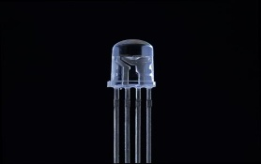
The same circuit as previously used was implemented again. This was a bit of a success. The MOSFETs were able to run the motors at maximum speed for up to one minute without failing. They did still get very hot though. To solve this, the MOSFETs were mounted onto heat-sinks with thermal grease compound on their backs. This kept the MOSFETs cooler than before, but the group felt that they were still getting a good deal hotter than they should be. There was a hold on the progress that was being made for about a week. Then one day an idea was proposed. It involved a small change to the motor controller circuit design. Ut was suggested that we try taking out the diode directly after the microcontroller input. It was also suggested that we try changing the resistor on the base or (gate in the case of the MOSFETs) from a 1k ohm to a 10 ohm. This reduced the heat of the MOSFETs dramatically. One last brilliant proposition was made. Use a parallel MOSFET design. In this way two MOSFETs would share the load of one. Testing was done with this set-up and it worked spectacularly. While running the motors the transistors were staying ice cold. After the entire team was satisfied with the results of the new and improved motor controller it was soldered together permanently. After the design was completed the final circuit needed to be permanently soldered together. In order to adhere to RoHS standards the group used silver-tin solder to make all the solder joints made for the final circuit. The RoHS standards state that tin-lead solder should not be used to avoid the long term health hazards involved with using products containing lead. The new and improved motor controller is set up as follows.
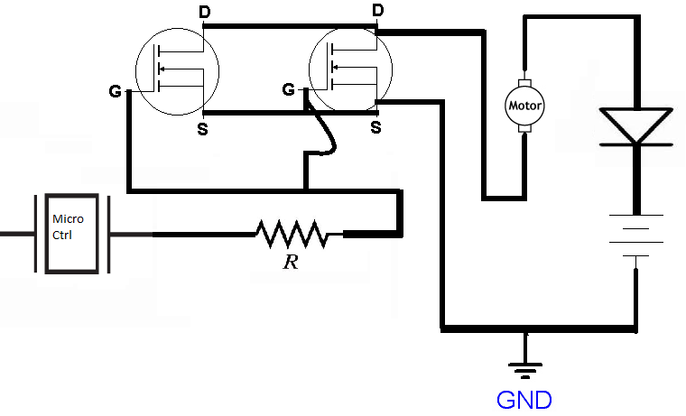
Implementation
Adam Gould

Now that everything was running as desired it was time to mount everything onto the helicopter to have it fly. All the circuitry and the Fio were added to the helicopter. The helicopter was able to lift all the equipment easily.

Modeling and Simulation:
Adam Gould

The Arduino Fio was used to control every process on the helicopter. The Arduino language which is a form of C was used to create the helicopter flight programs. One excellent method used for simulation of the helicopter program was using a tri-color light emitting diode (LED). This was a safe, low power and
very visually representative way to test programming with the Fio. Using this tri-color LED it was possible to simulate variation of motor control power level and timing. The tri-color added the extra benefit of being able test three Pulse Width Modulation pins on the Fio at once. Using each of the pins (red, blue, and green) on the LED to represent each of the three motors on the helicopter; it was possible to achieve some very useful simulations. Below is a program that demonstrates control over timing, and voltage signal strength which is what is required for motor control on the helicopter.

*/
int ledPin = 9; // LED connected to digital pin 9
int ledPin2 = 10; // LED connected to digital pin 10
int ledPin3 = 11; // LED connected to digital pin 11

void setup() {

// nothing happens in setup
}

void loop( ) {
// fade in from min to max in increments of 2 points:
for(int fadeValue = 0 ; fadeValue <= 235; fadeValue +=2) {
// sets the value (range from 0 to 255):
analogWrite(ledPin, fadeValue);
analogWrite(ledPin2, fadeValue);
analogWrite(ledPin3, fadeValue);
// wait for 50 milliseconds to see the dimming effect
delay(50);
}}

Testing
Adam Gould

A number of Arduino programs were tested on the helicopter. A pseudo code of exactly what the Arduino would have to do for a multitude of helicopter maneuvers can be seen below.

Helicopter takeoff:
do main motorpower at 35% power until Pingvalue = 5ft
if PingValue drops below 5ft (4.99ft) increment main motorpower by +5
if PingValue goes above 5ft (5.01ft) increment main motorpower by -5
(This altitude maintanence subroutine will be looped constantly throughtout the program unless otherwise specified)

Helicopter landing:
(enter helicopter landing loop)
do decrement main motorpower by -5 until PingValue = 0
main motorpower = 0

Basic Turning Subroutine:

Right Turn;
Increment Top main motorpower by +10
Decrement Bottom main motorpower by -10

Left Turn;
Increment Bottom main motorpower by +10
Decrement Top main motorpower by -10

Hard Right Turn;
Increment Top main motorpower by +30
Decrement Bottom main motorpower by -30

Hard Left Turn;
Increment Bottom main motorpower by +30
Decrement Top main motorpower by -30

Basic Forward Motion Subroutine:
Set tail motorpower to 75 using H-bridge and clockwise pin from microcontroller.

Fast Forward Motion Subroutine:
Set tail motorpower to 200 using H-bridge and clockwise pin from microcontroller.

Basic Backward Motion Subroutine:
Set tail motorpower to 75 using H-bridge and counterclockwise pin from microcontroller.

Fast Backward Motion Subroutine:
Set tail motorpower to 200 using H-bridge and counterclockwise pin from microcontroller.

Ascending Subroutine:
Increment main motorpower equally by +5

Descending Subroutine:
Decrement main motorpower equally by -5

Circle Subroutine:
Execute Forward Motion and Right Turn subroutines simultaneously or in a loop one after the other.

Ascending Circle Subroutine:
Execute Forward Motion and Right Turn and Ascending subroutines simultaneously or in a loop one after the other

Super Spin:
set Top main motorpower at 200
set Bottom main motorpower at 20

Object Avoidance Subroutine:
(This subroutine will be running constantly or a check for it and enter this subroutine if needed)
if PingValue = 12 in (or some value meaning that it is very near the helicopter)
pulse tail motorpower backward for a moment to put the breaks on.
(use a delay or timing function for this).
equalize main motorpower to make the helicopter hover
execute right turn until side Ultrasonic sensor is pinged at 12 in.
execute forward motion until SidePingvalue = 0
execute left turn 90 degrees.
execute forward motion for a couple seconds.

The team felt that with the above routine there is very little that the helicopter could not accomplish in terms of navigation and maneuvering. Below is the one that the helicopter demonstrated at Senior Design Fair. It is a program that runs the motors at various speeds to simulate ascending, descending, turn etc.

void setup() {
// initialize the digital pin as an output.

pinMode(11, OUTPUT);
pinMode(3, OUTPUT);
}

void loop() {

analogWrite(11, 255); // set the motor on
analogWrite(3, 255);
delay (2000);
analogWrite(11, 210);
analogWrite(3, 210);
delay (2000);
analogWrite(11, 200);
analogWrite(3, 200);
delay (2000);
analogWrite(11, 180);
analogWrite(3, 180);
delay (2000);
analogWrite(11, 165);
analogWrite(3, 165);
delay (2000);
analogWrite(11, 0);
analogWrite(3, 0);
delay (3000);
analogWrite(11, 165);
analogWrite(3, 165);
delay (2000);
analogWrite(11, 180);
analogWrite(3, 180);
delay (2000);
analogWrite(11, 200);
analogWrite(3, 200);
delay (2000);
analogWrite(11, 210);
analogWrite(3, 210);
delay (2000);
analogWrite(11, 0);
analogWrite(3, 0);
delay (3000);
analogWrite(11, 160);
analogWrite(3, 180);
delay (2000);
analogWrite(11, 200);
analogWrite(3, 250);
delay (2000);
analogWrite(11, 210);
analogWrite(3, 200);
delay (2000);
analogWrite(11, 100);
analogWrite(3, 0);
delay (3000);

// digitalWrite(4, HIGH); // set the LED off
// digitalWrite(5, HIGH); // set the LED off
// digitalWrite(6, HIGH); // set the LED off

// wait for a second
}

Due to the problem with the motor controller being solved so close to deadline not as much progress was made in testing as was desired. Another limiting factor was that an unforeseen problem resulted. If the battery on the microcontroller dies while the helicopter is running, the transistors will be destroyed. The team figured this out the hard way. Unfortunately the team used up all the NTE 2984s in Auburn and the surrounding areas. Replacement parts are being ordered but will not arrive until after the end of classes. Fortunately the team was able to get the helicopter working well and present it at the Senior Design Fair before this problem occurred. It is an easy one to solve given the required parts.

Component Design Details

Balancing the Helicopter

Shaquana Peterson

Our goal was to attempt to configure the helicopter with all of the required components such as sensors, microcontroller, batteries, etc., while keeping the weight of the payload to a minimum. We tested the payload of the helicopter with simply a plastic bag, a homemade harness, and couple of rocks from which we gathered from outside. We then attached the plastic bag to the harness that was attached to the bottom of the helicopter and added one rock at a time. We then flew the helicopter to see if it would be able to carry the load. We repeated this procedure until we reached the maximum amount of rocks that the helicopter was able to hold while in flight. We reached the weight of about four medium sized rocks, in which we then concluded that the helicopter would be able to easily hold all of the components, because the weight of the rocks was much more than the weight of all of the components that we plan to attach to the helicopter. In order to attach the necessary components, we plan to use zip-ties or velcro straps so that we can move the sensors or components very easily if needed. For our sensor system, we plan to attach a sensor in the front of the helicopter to detect obstacles in its path, a sensor underneath the helicopter to control its elevation, and a sensor on both the right and left side of the helicopter to detect wall distance, parallelism, and wall following. Since we are adding items to the helicopter, we definitely want to make sure that the helicopter remains balanced. We plan to use the weight of the power supply to achieve an even amount of weight distribution, therefore helping the helicopter to maintain its balance. Since Cycle one, we ran into a bit of a time constraint. As a result, we were unable to incorporate the use of the sensors which would have been used to drive the motors on the helicopter according to specific distance readings. The reason for this time constraint is that we spent a lot of time trying to figure out how to get the motors to work properly; we couldn’t figure out if the motors were getting enough voltage or if it was a current issue. Although we later found out that the motors weren’t receiving enough current, it was too late to go further with using the sensors, so we just relied on the Arduino program to control the motors. We also thought that it might have been a good idea to use guarded blades and cover up the circuitry that we used on the helicopter, as safety precautions, but we were also unable to deal with these issues due to time constraints.

Arduino Fio Testing

Adam Gould

To successfully create a helicopter that can fly autonomously, a micro-controller with the proper programming is essential. Team one resolved to purchase three separate micro-controllers for the design project. All three of the controllers are Arduinos. One of them is an Uno model and the other two are Fio models. To effectively use the micro-controllers it was first necessary to become familiar with the way that they function and the language that is used to program them. Basically this is what is entailed to be able to use the micro-controllers for our project.

All of testing that was accomplished was done using the Arduino Fios. The first step in learning to use the Fio was to become familiar with the pin locations and the function that each pin was designated for. Some of the functions include power, ground, inputs, outputs, and pulse width modulation. The next step was to connect the Fio to a computer.

To successfully connect the Fio to a computer an adapter is required. With the adapter installed correctly the Fio has the potential to be uploaded with programs from the computer. Before a program can actually be loaded onto the Fio it was necessary to download both the programming software and drivers for the Fio. Next step was to change several settings inside the programming software itself such as which port the micro-controller was being read from.

From there the next objective was to learn about and become proficient in using the programming language that the Fio operates with. This was done by studying several example programs that were provided on the Arduino website. After perusing several example codes it became apparent that the language that the Fio operates with is similar to the programming language C.

To become comfortable using the Fio the team began to write simple codes to test the capabilities of the Fio. The first was simply to send out a high to a green led to make it light up. This was accomplished without too much difficulty. Then it was on to making the led blink at various intervals. After some level of comfort was achieved it was time to start coming up with code that more resembled what the program that would be controlling the helicopter would actually have to do.

xBee Wireless Communications

Jens Johnson
The transceiver we were using is the 2.4GHz XBee module XB24-AWI-001 from Digi. These modules take the 802.15.4 stack and wrap it into a simple to use serial command set. These modules allow a very reliable and simple communication between microcontrollers, computers, and systems. Point to point and multi-point networks are also supported.
To start, the xBee is placed on the shield. Then, a set up code is initiated using the FioXBeeConfigTool interface. The interface is a GUI that configures the xBee to either be the programming radio or the fio controller radio.
Since our design approach changed, we no longer needed the transceivers. And thus no further effort or work was put in to establish reliable communication between the two modules.

Power Supply for PING))) Ultrasonic Sensors

David Mason
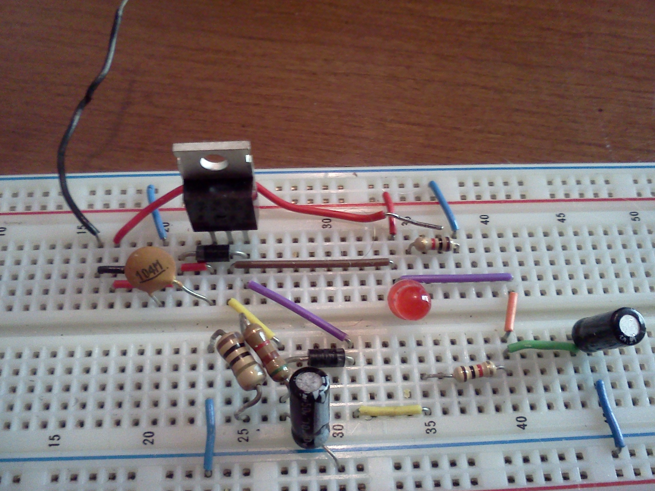
In order to provide the helicopter with a “sense of sight” the team decided to use PING))) ultrasonic sensors to judge distance. The problem that arose with using the ultrasonic sensors was that they required a constant voltage of 5V DC to work properly.

In previous designs a different microcontroller, the Arduino Uno, was being used which provided a 5V output pin. Preliminary testing showed that the power used by the ultrasonic sensor was too high for the microcontroller to function properly. This resulted in the decision to construct a standalone power supply for the sensors. The power supply constructed utilized an LM334 power regulator and a 9V battery to provide a 5V output voltage. The following diagram shows the schematic of the power supply circuit used for the sensors.
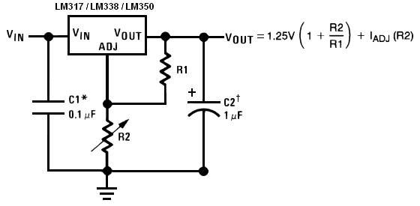

Testing and Prototyping the PING))) Ultrasonic Sensors

Edward Budimier

The sensor we will be using for forward and side detection is Parallax’s PING))) ultrasonic sensor. These sensors simply require a 5 Volt DC source pin and another to ground. Its third pin sends the results of sonar distance detection to our microcontroller to determine the helicopter’s surroundings. We will be using three of these sensors to detect the distances on the horizontal plane, as opposed to the one IR sensor used for determining the vertical height of the helicopter. Below are the features of the Ultrasonic Sensor.

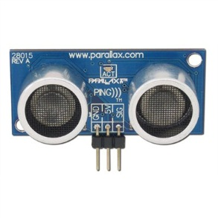
Features:
- Precise to within a 2 cm to 3 m range
- Pulse in/pulse out communication
- Burst LED shows measurement in progress
- 20 mA power consumption
- 3-pin header
In order to write a program to utilize this sensor, the time it takes for one pulse to return must be used to calculate the distance being sensed. I also had to program using the Arduino software. Keeping this in mind, I looked to an example program for an ultrasonic sensor. I found an equation that translated my signal into correct distances from the sensor.

I took the basic example code that was provided, and modified it to do different actions at different distances. At first seeing if it was working, the different distance ranges turned on different LED’s. This showed me that these sensors can easily be used to act as interrupts in our helicopter’s main program, letting it know that it needs to watch out for walls or other obstacles. Below is the code I wrote for the single ultrasonic sensor.

//Ultrasonic sensor with use of LED's for proof of function

int pingPin = 2; //ultrasonic sensor signal pin on arduino controller
int near = 4; //LED pin used to show an object is very close
int closer = 7; //LED pin used to show an object has been observed getting closer
int far = 8; //LED pin used to show that no object is close by

void setup() {
// initialize serial communication:
Serial.begin(9600);
pinMode(near, OUTPUT);
pinMode(closer, OUTPUT);
pinMode(far, OUTPUT);
}

void loop()
{
// establish variables for duration of the ping,
// and the distance result in inches and centimeters:
long duration, inches, cm;
char warninga[] = " Danger Close"; //text output when an object is sensed very close by
char warningb[] = " Object Approaching"; //text output when an object is observed to be getting to be too close
char warningc[] = " Clear Path"; //text output when nothing is observed in a safe range

// The PING))) is triggered by a HIGH pulse of 2 or more microseconds.
// Give a short LOW pulse beforehand to ensure a clean HIGH pulse:
pinMode(pingPin, OUTPUT);
digitalWrite(pingPin, LOW);
delayMicroseconds(2);
digitalWrite(pingPin, HIGH);
delayMicroseconds(5);
digitalWrite(pingPin, LOW);

// The same pin is used to read the signal from the PING))): a HIGH
// pulse whose duration is the time (in microseconds) from the sending
// of the ping to the reception of its echo off of an object.
pinMode(pingPin, INPUT);
duration = pulseIn(pingPin, HIGH);

// convert the time into a distance
inches = microsecondsToInches(duration);
cm = microsecondsToCentimeters(duration);
//All of these serial.print commands give me a clean display of distance in inches and centimeters, and a warning depending the distance from the sensor
Serial.print(inches);
Serial.print("in, ");
Serial.print(cm);
Serial.print("cm");
if (inches <= 4){
Serial.print(warninga);
digitalWrite(near, HIGH);
digitalWrite(closer, HIGH);
digitalWrite(far, HIGH);
}
if (inches > 4 && inches <=8){
Serial.print(warningb);
digitalWrite(near, LOW);
digitalWrite(closer, HIGH);
digitalWrite(far, HIGH);
}
if (inches >8){
Serial.print(warningc);
digitalWrite(near, LOW);
digitalWrite(closer, LOW);
digitalWrite(far, HIGH);
}

Serial.println();

delay(100);
}

long microsecondsToInches(long microseconds)
{
// According to Parallax's datasheet for the PING))), there are
// 73.746 microseconds per inch (i.e. sound travels at 1130 feet per
// second). This gives the distance travelled by the ping, outbound
// and return, so we divide by 2 to get the distance of the obstacle.
// See: http://www.parallax.com/dl/docs/prod/acc/28015-PING-v1.3.pdf
return microseconds / 74 / 2;
}
long microsecondsToCentimeters(long microseconds)
{
// The speed of sound is 340 m/s or 29 microseconds per centimeter.
// The ping travels out and back, so to find the distance of the
// object we take half of the distance travelled.
return microseconds / 29 / 2;
}

Control Logic

Jens Johnson
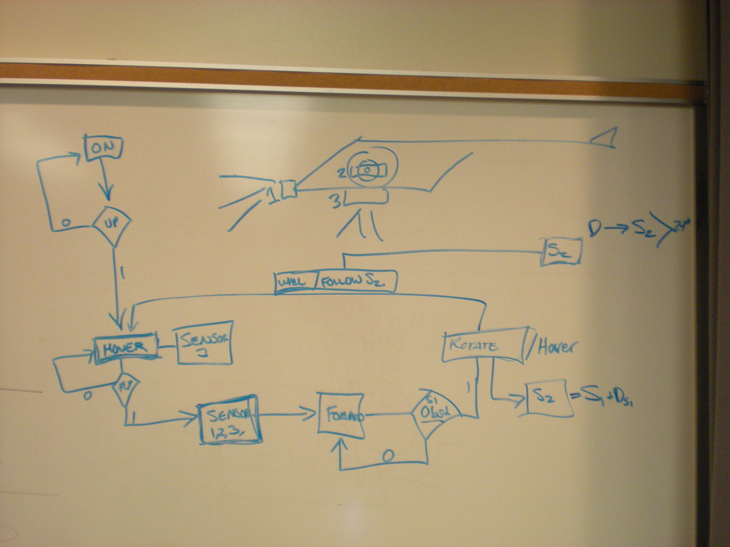
The idea behind the logic diagram is to provide some direction of what the overall code needs to accomplish as it executes. In an earlier team meeting we established our basic design using a white board.

For reference purposes the image below depicts the sensors and their prospective positions on the helicopter. Each sensor is labeled S1-S4.

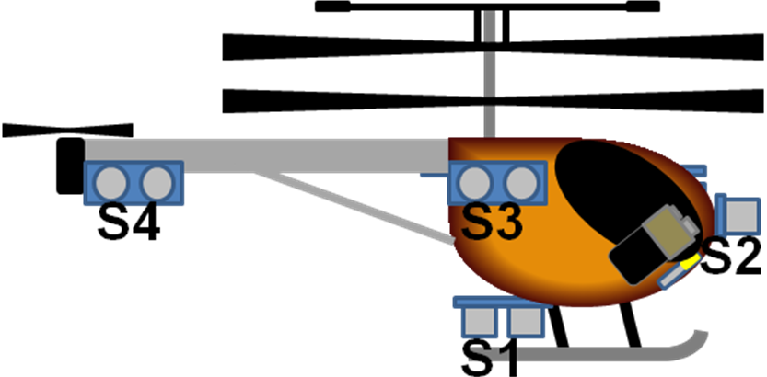
Below are three stages in the flight execution that were looped and referenced to ensure correct system response. Firstly is the HOVER loop. In this loop S1 is the sole applicable sensor being used. S1 will determine how high off the ground the helicopter is. Once the sensor information is acquired it will be transmitted to our control board for analysis. Based on the results of the measurement the Helicopter will either increase or decrease lift.

Once a flight altitude is established, the helicopter can begin FORWARD movement. While in forward movement the system will passively be looping the hover command while looking for obstacles with S2. The Helicopter will continue to fly until S2 triggers an interrupt with its measurement.

At the onset of an obstacle the TURN command will execute. Turning will commence and will only stop when S3 and S4 are equal in value. This will ensure that the helicopter is going to fly parallel to the obstacle. And thusly will the autonomous flight continue.

In the diagram below the red arrows are logic 0, or no, and the green arrows are logic 1, or yes. The blue arrows are mandatory progressions. The dark blue boxes are subroutines, while the light blue boxes are logic inferences.

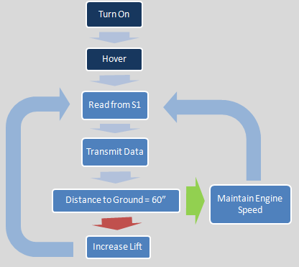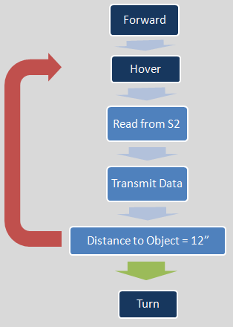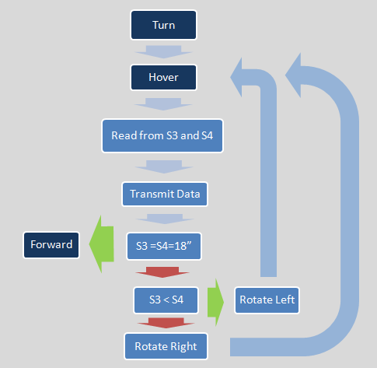

Below is the final code. Unfortunately, our project never quite made it to that stage. The final code is designed to take off, track a wall, turn four times, and then land. The motor speeds were estimated and would need to be modified once the in-flight tests were finished. Asterisks were inserted in locations that required specific, but yet to be identified, numbers.

The code was further simplified using a subroutine to read in from the sensors rather than having to code in every time the sensor was read. Upon landing the helicopter would stay in an infinite loop with the motors off so that the handler could retrieve the helicopter with ease. This code is easily modifiable to initiate all of the maneuvers outlined in the pseudo-code above. Reading the sensors and determining the next course of action is as simple as running the subroutine for the sensor and placing the result into a conditional statement. This program could be easily edited to support additional sensors as well.

//Main program to run the AUtocopter

//Pin Assignment
long pingPina = ***; //first ultrasonic sensor signal pin (forward facing)
long pingPinb = ***; //second ultrasonic sensor signal pin (wall facing, forward-most)
long pingPinc = ***; //third ultrasonic sensor signal pin (wall facing, rear-most)
long pingPind = ***; // infared sensor signal pin (ground facing)

int motor1 = ***; //output to control the rotor1 motor
int motor2 = ***; //output to control the rotor2 motor
int motor3 = ***; //output to control the tail rotor motor

void setup() {
// initialize serial communication:
Serial.begin(9600);
pinMode(motor1, OUTPUT);
pinMode(motor2, OUTPUT);
pinMode(motor3, OUTPUT);
}

void loop(){

// establish variables for duration of the ping and the distance result in inches:

long inchesa, inchesb, inchesc, inchesd;
int takeoff = 0, numberOfCorners = 4;

//*********************************************************************
//***************************Take Off**********************************
//*********************************************************************

inchesd = readSensor(pingPind);

if (takeoff = 0){
while (inchesd < 24){
analogWrite(motor1,150); //Adjust lift speed as desired
analogWrite(motor2,150);
inchesd = readSensor(pingPind);
}

analogWrite(motor1,100); //100 is the assumed motor speed for hovering, analogWrite(motor2,100);

takeoff = 1;
}

//*********************************************************************
//*******************Going Forward, no obstacle************************
//*********************************************************************

inchesa = readSensor(pingPina);

while (inchesa > 18){
//Motor Response

analogWrite(motor3,***); //assign motor speed to attain forward flight

inchesb = readSensor(pingPinb);
inchesc = readSensor(pingPinc);
inchesd = readSensor(pingPind);

if (inchesb < inchesc){
analogWrite(motor1,110); //Adjust slightly to the left, analogWrite(motor2,100);
delay(100); //Delay to account for adjustment
}

if (inchesb > inchesc){
analogWrite(motor1,100); //Adjust slightly to the right, analogWrite(motor2,110);
delay(100);
}

if (inchesd < 24){
analogWrite(motor1,120); //increase in elevation, analogWrite(motor2,120);
delay(200);
}

if (inchesd > 36){
analogWrite(motor1,80); //decrease in elevation, analogWrite(motor2,80);
delay(200);
}

analogWrite(motor1,100); //100 is the assumed motor speed for hovering
analogWrite(motor2,100);

inchesa = readSensor(pingPina);
}

//*********************************************************************
//********************Obstacle encountered and Turning*****************
//*********************************************************************

if (inchesa < 18 ){
//Motor Response
analogWrite(motor3,0);
analogWrite(motor1,125); //motors are offet to make the heli spin
analogWrite(motor2,75);
delay(500); //Half of a second delay to start spin

inchesb = readSensor(pingPinb);
inchesc = readSensor(pingPinc);

while(inchesb != inchesc){
analogWrite(motor1,125); //motors are offet to make the heli spin
analogWrite(motor2,75);
inchesb = readSensor(pingPinb);
inchesc = readSensor(pingPinc);
}

inchesa = readSensor(pingPina);
}

//******************************************************************
//***********************Landing************************************
//******************************************************************

while(numberOfCorners = 0){

inchesd = readSensor(pingPind);

while(inchesd > 2){
analogWrite(motor1,75); //needs to be adjusted to initiate a slow descent.
analogWrite(motor2,75);
analogWrite(motor3,0);

inchesd = readSensor(pingPind);
}

analogWrite(motor1,0);
analogWrite(motor2,0);
analogWrite(motor3,0);
}

--numberOfCorners;
}

//********************************************************************
//*********Convert sensor response time into a distance***************
//********************************************************************

long microsecondsToInches(long microseconds)
{
return microseconds / 74 / 2;
}

//********************************************************************
//*****************Get a reading from the sensors*********************
//********************************************************************

long readSensor(long pingPin)
{
long duration, inches;

// The PING))) is triggered by a HIGH pulse of 2 or more microseconds.
// Give a short LOW pulse beforehand to ensure a clean HIGH pulse:

pinMode(pingPin, OUTPUT);
digitalWrite(pingPin, LOW);
delayMicroseconds(2);
digitalWrite(pingPin, HIGH);
delayMicroseconds(5);
digitalWrite(pingPin, LOW);

// the same pin is used to read the signal from the PING))): a HIGH
// pulse whose duration is the time (in microseconds) from the sending
// of the ping to the reception of its echo off of an object.

pinMode(pingPin, INPUT);
duration = pulseIn(pingPin, HIGH);

//distance conversion
inches = microsecondsToInches(duration);

return inches;
}

LOGISTICS

Timeline

Edward Budimier

Below is the timeline with actual completion dates represented as of March 8th 2011; also shown below is a Gantt Chart with a final date of May 6th 2011. Creating a timeline and setting goals is an important part of the design process. At the beginning a team has to be honest about their capabilities and limitations and set forth realistic goals and expectations for the time ahead. Looking at the original timeline and comparing it to what we actually did, it’s easy to see that the best laid plans do not always survive the actual process. A prime example being the time spent on wireless communication. We thought it would be a big part of our helicopter control system and so we allocated quite a bit of time to working with wireless chips. Due to communication problems between the chips and the frying of the helicopter controller, we switched our wireless plans to more programming of the onboard microcontroller. We had planned for the waiting periods involved with waiting for parts, but not for the parts to arrive and then not be useful for what we needed causing a large misuse of time; though the waiting periods did allow us to explore alternate options for the final circuit design on the helicopter. The ability to complete the final prototype was hindered by waiting on parts and deciding which parts would go on the helicopter for proper weight distribution.

Project Schedule
Activity | Cycle 1 |  |  |  | Cycle 2
Activity | 10FEB-16FEB | 17FEB-23FEB | 24FEB-2MAR | 3MAR-9MAR | 10MAR-16MAR |  | 17MAR-23MAR |  | 24MAR-30MAR | 31MAR-6APR | 7APR-13APR | 14APR-20APR
Wireless Communication
Balance Helicopter
Program Ultrasonic Sensors
Program IR Sensor
Repairs and ordering parts
Complete Prototype
Prototype testing
Complete Project
Milestones
1. Performance of sensors confirmed
2. Communication between microcontroller and helicopter controller confirmed
3. Developed a logic flowchart for helicopter's autonomous actions
4. Mounted Necessary parts onto helicopter and begin prototype testing
5. Helicopter tested to ensure proper autonomous function


Budget

Shaquana Peterson

Budgeting is very important in every financial plan. A good budget can help keep your spending under control and even leave room to put the extra money toward any other financial needs that may occur. So, with keeping the need for a good budget in mind, we first discussed our approach for the design of our project so that we could produce an effective budget. We then researched some of the same general parts and compared pricing on each item with the aim to come up with the cheapest, yet effective products. We decided to buy a commercially available helicopter rather than constructing our own, because we established that it will help to maintain a sufficient budget as well as create space for the amount of time needed for trial and error. We then constructed the table as shown below, which displays the cost of each product as well as the total estimated cost for the project.

Component | Supplier | Unit Cost | Quantity | Total Cost
3.5-Ch Metal Outdoor RC Helicopter Volitation 9053 | EToysWorld.com | $68.25 | 1 | $68.25*
Arduino Fio | sparkfun.com | $24.95 | 1 | $24.95*
RC Control Board | Fevertoys.com | $17.39 | 1 | $17.39*
FTDI Basic Breakout | sparkfun.com | $14.95 | 1 | $13.95*
Polymer Lithium Ion Battery 20 mAh | sparkfun.com | $8.95 | 1 | $5.95*
Updated Main Rotor Blade Set A And B 4 Pc For The Double Horse 9053 Gyro Helicopter | Superstition Hobbies | $8.24 | 1 | $8.24**
Break Away Headers - Machine Pin | sparkfun.com | $2.95 | 1 | $2.95*
NTE2984 MOSFET Transistor | Southern Electronics | $1.75 | 4 | $7.00**
Heat Sinks | Radio Shack | $1.99 | 4 | $7.96**
Triple Output LED RGB-Clear | sparkfun.com | 1.95 | 2 | $3.90*
PCB Control Board | Radio Shack | $1.99 | 2 | $3.98**
Motor Driver | sparkfun.com | 44.78 | 1 | $44.78*
9V Snap Connector | sparkfun.com | $1.25 | 1 | $1.25*
9V to Barrel Jack Adapter | sparkfun.com | $2.95 | 1 | $2.95*
Actual Budget |  |  |  | $250.00
Total Estimated Project Cost |  |  |  | $213.50**

*Note: Shipping and handling not included.
**Note: Taxes not included.

Inventory and Components

Shaquana Peterson

Components | Description
3.5-Ch Metal Outdoor RC Helicopter Volitation 9053  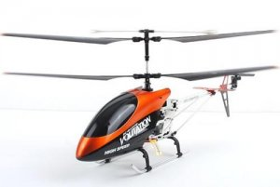 | Full function 3 channel radio control (Left /Right, Forward/Backward, Hover, and Lands)  Real life helicopter styling  3 channel digital proportional control  Built in Gyro for Extra Stability  Unique material withstand crashes  Flies over 100m high  2 powerful 180 main motors + N20 tail motor!
Arduino Fio  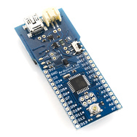 | Used to input data from sensors and IO from computer to run helicopter and controller
RC Control Board | Replacement control board for helicopter
FTDI Basic Breakout  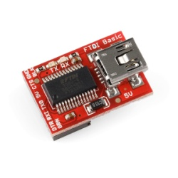 | Used to import data from the Arduino Fio and the computer
Polymer Lithium Ion Battery-20mAh  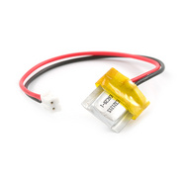 | Used to power the Arduino on the helicopter
Updated Main Rotor Blade Set A And B 4 Pc For The Double Horse 9053 Gyro Helicopter  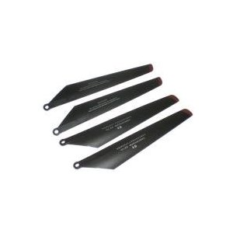 | Extra blades for RC helicopter
Break Away Headers-Machine Pin  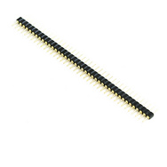 | This is a very large row of high quality machine pin headers - break to fit. 40 pins that can be cut to any size. Used to connect different components together
NTE2984 MOSFET Transistor | Logic Level MOSFET  N–Channel, Enhancement Mode  High Speed Switch
Heat Sinks  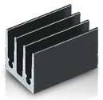 | This premium aluminum heat sink provides better heat dissipation than standard pressed sheet metal heat sinks and ensures heat transfer between semiconductor device and the heat sink.
Triple Output LED RGB-Clear  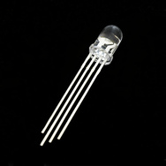 | Use this one LED for three status indicators or pulse width modulate all three and get mixed colors
PCB Control Board  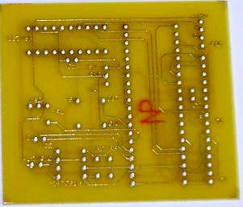 | Insulated board on which interconnected circuits and components are mounted or etched.
Motor Driver  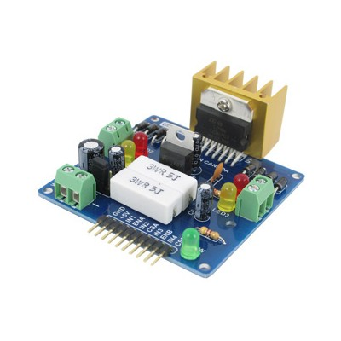 | This dual bidirectional motor driver will allow you to easily and independently control two motors of up to 2A each in both directions.
9V Snap Connector  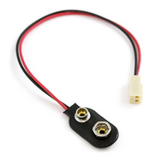 | Classic 9V connector terminated with 2-pin polarized Molex connector. 5" in length used to power Arduinos
9V to Barrel Jack  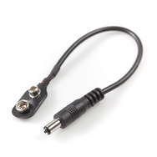 | Use this cable to battery-power Arduinos

REVIEW

Overall Project

Accomplishments
Jens Johnson

Our group was able to accomplish a great deal. Even though we suffered numerous setbacks we were able to develop a working model that was just shy of our original goal. We were able to:
- Establish motor control of all the rotors simultaneously.
- Use sensor readings to set motor speed.
- Manage our circuit’s heat and power consumption.
- Keep our overall weight to a minimum and still achieve stable flight.
The only pieces of the equation that we were unable to complete within our timeframe were the final flight test measurements to establish an in-flight motor speeds to hover, turn, and land the helicopter. Our issues designing a functional motor controller really ate into our time to create our desired end product. However, we still feel like this project was a success.

Reflection
Jens Johnson

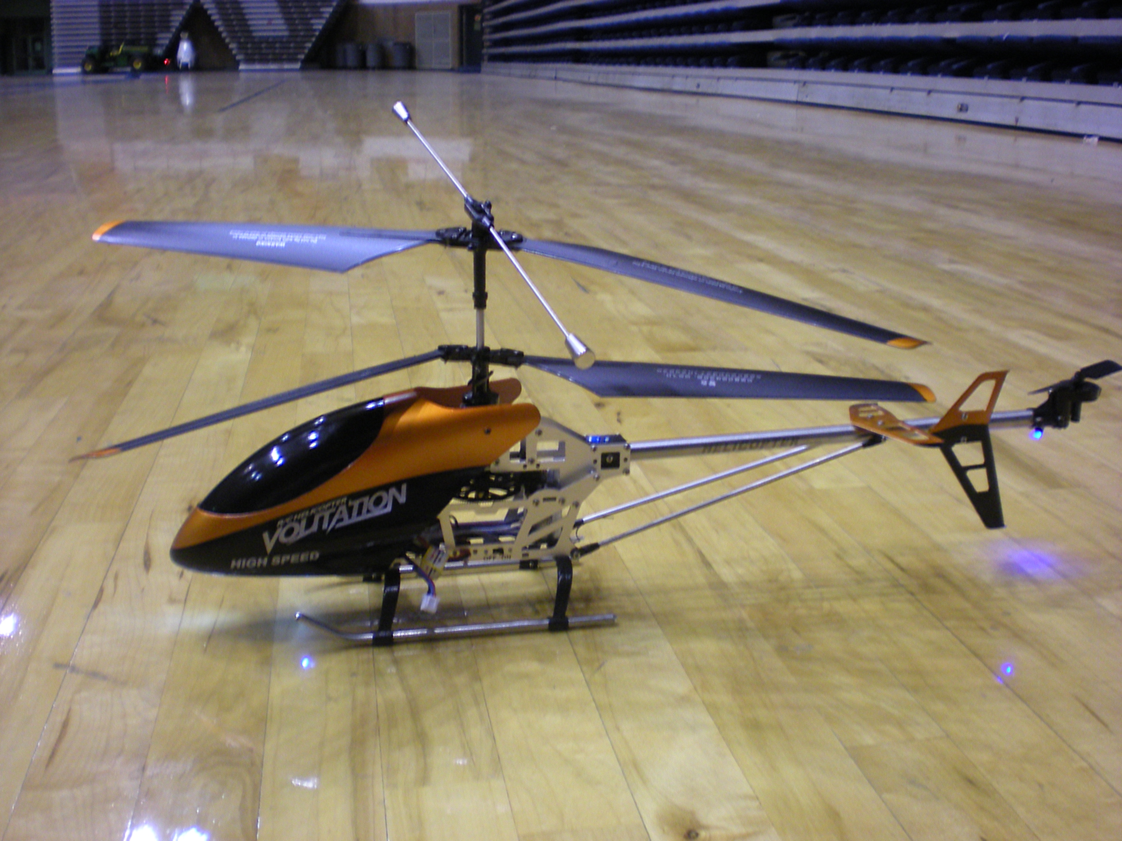
Reflecting back at how we managed our project and how we dealt with our realistic constraints we now understand the value of constant communication and time management. Our major constraint was not using adequate care while testing our circuits resulting in damaged equipment. The delay to replace the damaged parts really impaired our progress on the overall project. If we could have had more time we believe that we would have finished our project with all of the initial design parameters desired. If we could do it over again we would have perhaps attacked our problems simultaneously implementing multiple design solutions and used the optimal result within our time requirements.

The only design modification that perhaps would have been made would be the mounting a GPS module on the helicopter and plotting the sensor readings using a ROS program to navigate the environment. This design, however, exceeded our budget limitations early in the semster.

The Design Team


Ed Budimier: Is a senior in the Electrical Engineering program at Auburn University. Ed hopes to use the problem solving skills and knowledge gained in the EE program to complete this project, and also in his career as a Combat Engineer in the Marine Corps


Adam Gould: Is a senior in the Electrical Engineering program at Auburn University. His focus is robotics.


Jens Johnson: Is a senior in the Computer Engineering program at Auburn University. His focus has been on Networks, Digital Forensics, and Hardware Architecture.


David Mason: Is a senior at Auburn University working toward his first Bachelors degree in Electrical Engineering. He is 26 years old and has been married for 3 years. His technical interests include Robotics, Control Systems, Electronics, and PC hobby and repair.


Shaquana Peterson: Is a senior working toward her first Bachelors degree in the Electrical Engineering program at Auburn University. Her technical interests include Electronics and Electrical

